TAC Masters Update 24th August
SCVAC Track and Field Finals Ashford 3rd September
We are getting to close to this event now. There have been one or two drop outs and changes. I have sent a latest team sheet and timetable out by email. Please bear in mind that this may be subject to further changes and check your individual commitments with regards to the timetable.
Sadly, Irena has had to withdraw due to injury which may well keep her out for the whole of next season as well. We need to find a replacement sprinter for the W50 age group (FFFF Fleet of Foot Fifty year old Female!) Anyone out there looking at this please get in touch.
Relay practice this Sunday at 11am for all participants who can make it.
General team practice on Sunday, we will try to get all field events available.
Join the facebook group https://www.facebook.com/groups/1725755161043753/

SAL Tonbridge
I am sure most of you will have heard how the TAC Southern Athletics league team missed promotion back to the first division by the narrowest margin possible, Half a match point, having tied for second place!
It was great to see Di Bradley and Maria Heslop contributing good points on the track and in the field. Angie Crush stepped in on the Friday night to do the Pole Vault (equalling the Clubs W40 record 1.70m), 1500m B string and the 400m B string. Angie collected 6 points, along with Maria’s 5and Di’s 2, this very nearly helped to achieve promotion. The lesson from this season for the SAL team is to cover the Women’s events and the Vets women can be important contributors next year. So please make yourselves available where possible.
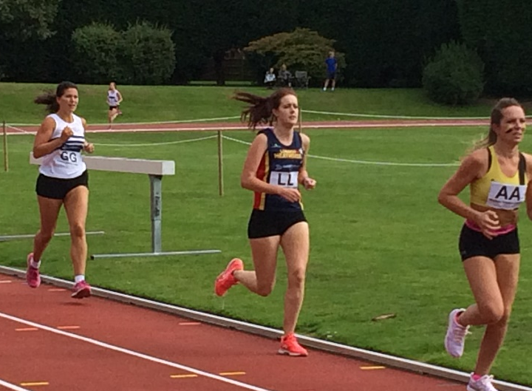
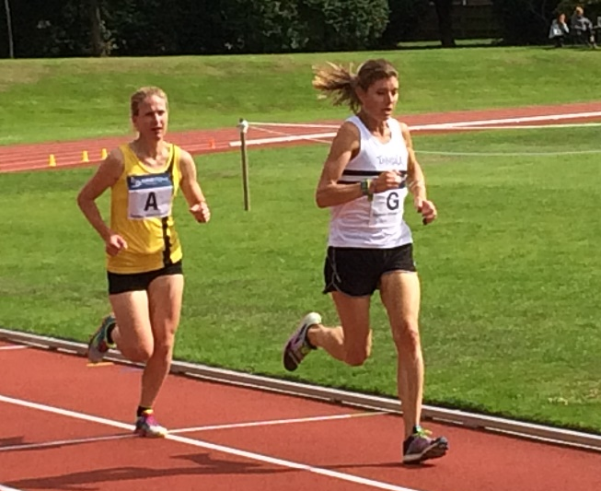
ParkRun
Well done Graeme Saker who is still racing in the 17 minutes for 5km!! He ran 17.47 last week. Still setting a target for the rest of us!!
Also good runs from Alan Buckle 19.23 at Tonbridge to move to 6th on the 55-59 ranking.
Adam Roeder is continuing to cut his PR times and recently ran 19.03 at Bromley. Having achieved his sub 20 target he is now targeting sub 19!
Southern Road Relays Crystal Palace
If you have not done so yet please return the Winter availability forms to Mark Hookway. Make sure he knows you are wanting to race in the Southern Road Relays at Crystal Palace. We try to make complete teams either vets or Senior , but if we have extra Vets runners then he will combine them with extra senior runners to complete a team rather than having two incomplete teams. Everyone will be racing at the same time on the same course. There are only 4 team members for the vets (Men and Women) as opposed to 6 in the Senior Mens.
We are defending M50 team champions so we need to put up a good defence!!!
As a vet you can take part in all events apart from the National Road Relays (we have Vets one in May) and the National XC Relay at Mansfield. The Kent XC leagues are very suitable (10Km and quite local) and the Blackheath Relays are a relaxed good first XC run over 4km each runner.
Research Findings
Below is the report on a research project that at least 4 of us took part in earlier in the year to look at psychology of sport. It involved running 5Km on a treadmill 4 times with a preload of 6 minutes at a set speed before each run. There were various questions to answer before, during and after relating to expectations, how you felt at the time, reasons for how you performed etc. The sting in the tail was that unknown to us he increased the incline from 1% to 2% for either the 3rd or 4th 5km run. Personally I found it tough on the extra incline and had to reduce the speed after 2km, then all sorts of negative thoughts dominated as I was not going to meet my target time etc However afterwards (before I knew about the incline) I clearly reasoned that I had a cold etc and tried to forget the run!!! Interesting confirmation of what we probably understand as experienced runners.
Results for Participants
What was the study about?
The current study looked to examine the role of self-efficacy in 5km time trial performance. Self-efficacy represents what we believe we can do. Research has consistently demonstrated that what people believe they can do is often a better predictor of performance than what they are objectively capable of. Most of us probably know someone who, while possessing the needed physical ability, sometimes fails to perform in races or competitions. Self-efficacy is likely to be an important factor behind this. When people possess higher levels of self-efficacy they set themselves more challenging goals, are more willing to push themselves physically, and are more likely to persevere when faced with obstacles. As you can see, self-efficacy is likely to play a very important role in endurance sport.
In the current study we were primarily interested in examining the role of self-efficacy when runners experienced a simulated ‘bad day’. Performance is relatively straightforward when we are not faced with obstacles or difficulties, but this is unlikely to occur in real world settings. We brought this ‘bad day’ about by changing the incline of the treadmill on one of the runs from 1% to 2%. Although this represents a relatively small change in task difficulty, it is enough for the exercise to feel harder than normal. As self-efficacy is linked to both effort and perseverance we hypothesised that the higher the level of self-efficacy, the less the change in performance on the 2% incline run.
Who took part?
Participants were twelve male (mean age = 38.5 years, mean height = 178cm, mean weight = 69kg, mean o₂max = 60ml·kg-1 ·min-1) and six female (mean age = 43 years, mean height = 169cm, mean weight = 60kg, mean o₂max = 52ml·kg-1 ·min-1) runners. Participants had been engaging in competitive running for an average of 15 years, and were training 10 hours a week on average. 5km personal best (Pb) over the last year was 19:53 ± 2:16 minutes for men, and 22:36 ± 3:09 for women.
What were the main findings?
Unsurprisingly, performance was significantly slower on the 2% incline run, as well as it feeling more difficult (the perception of effort was higher), more painful, and participants had a worse mood during it. In regards to self-efficacy, we found that individuals who scored highly on a scale of endurance sport self-efficacy had less of a drop in performance during the 2% condition than those who scored lowly on the scale. Interestingly, they still rated the 5km run as being just as difficult and as painful, therefore, suggesting that self-efficacy didn’t alter how much pain or effort they felt, but instead encouraged them to tolerate it more.
In regards to the preload (the 6 minutes of fixed running before the 5km run), we found that following the 2% incline preload, self-efficacy for the upcoming 5km was significantly lower. Specifically, participants felt they could still achieve a similar time, but were less certain in this belief. This is interesting because it highlights how small changes in what we expect to feel, can have an influence on our beliefs for an upcoming event. This has potential implications for what we should encourage athletes to do if their warm up does not go to plan before a race.
The reasons that people gave for their performance was also different in the 2% compared to the 1% incline conditions. Following the 2% run, participants were more likely to ascertain their performance to unstable, temporary external factors. This helps support previous research which suggests when individuals have poor unexplained performances they often blame external factors outside of their control, as this helps them maintain their sense of self-efficacy.
What are the next steps?
The current study helps provide further evidence for the role and importance of self-efficacy in endurance performance, specifically running. As self-efficacy was associated with increased perseverance when faced with an unexpected difficulty (the change in incline), promoting a high and strong level of self-efficacy is likely to be very important for runners, and endurance athletes in general. The next stage of research looks to take the findings from the current and previous studies, in order to help design and deliver psychological interventions which are aimed at helping to increase self-efficacy.

