**Osgood Schlatter Strength Exercises**

1. Lie on your back with your good knee bent so that your foot rests flat on the floor. Your affected leg should be straight. Make sure that your low back has a normal curve. You should be able to slip your hand in between the floor and the small of your back, with your palm touching the floor and your back touching the back of your hand.
2. Tighten the thigh muscles in your affected leg by pressing the back of your knee flat down to the floor. Hold your knee straight.
3. Keeping the thigh muscles tight and your leg straight, lift your leg up so that your heel is about 30 cm (12 in.) off the floor.
4. Hold for about 6 seconds, then lower your leg slowly. Rest for up to 10 seconds between repetitions.
5. Repeat 8 to 12 times.

**Straight-leg raises to the**

**front** 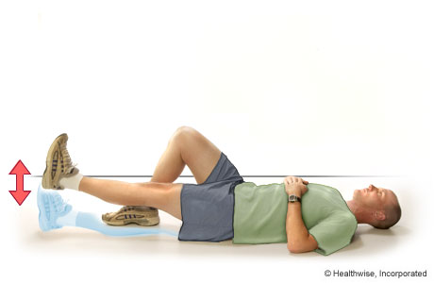

1. Lie on your back with your knees bent over a foam roll or large rolled-up towel and your heels on the floor.
2. Lift the lower part of your affected leg until your leg is straight. Keep the back of your knee on the foam roll or towel.
3. Hold your leg straight for about 6 seconds, then slowly bend your knee and lower your heel back to the floor. Rest for up to 10 seconds between repetitions.
4. Repeat 8 to 12 times.

**Short-arc quad**

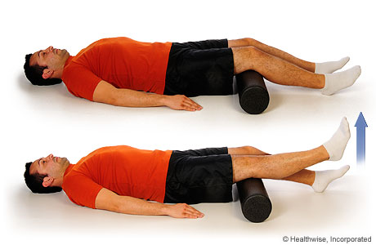

**Shallow squat with knees**

1. Stand with your feet about shoulder-width apart and turned out to the sides about 45 degrees.
2. Keep your back straight and tighten your buttocks.
3. Slowly bend your knees to lower your body about one-quarter of the way down toward the floor. Do not let your knees extend beyond the tip of your toes and keep your heels on the floor.
4. Repeat 8 to 12 times.

**and feet turned out**

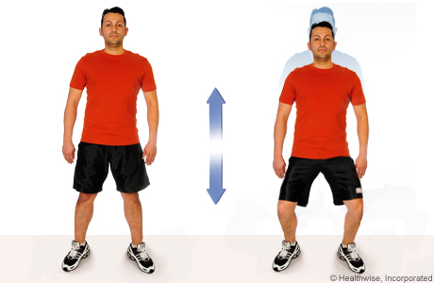

1. Tie the ends of an exercise band together to form a loop. Attach one end of the loop to a secure object or shut a door on it to hold it in place. (Or you can have someone hold one end of the loop to provide resistance.)
2. Loop the other end of the exercise band around the knee of your affected leg. Keep that leg somewhat bent at the knee.
3. Put your good leg about a step behind your affected leg. Then slowly straighten your affected leg by tightening the thigh muscles of that leg.
4. Hold for about 6 seconds, then return to the starting position with your knee somewhat bent.
5. Rest for up to 10 seconds.
6. Repeat 8 to 12 times.

**Terminal knee extension**

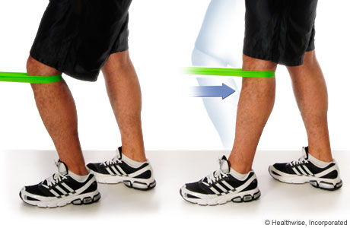

Bridges with Band

1. Lie on you back with band around your knees & knees bent.
2. Push your hips up so there is a straight line between shoulders & knees pushing knees out slightly against the resistance of the band.
3. Tighten your buttocks & hold for 30 secs or 3 x 10 sec holds

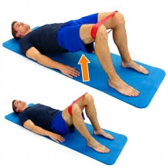

1. Lie with back on the floor & feet on a fitball or chair.
2. Push up through your hips so there is a straight line between shoulders & ankles, use your arms to stabilise your body.
3. Hold for 30 secs or 3 x 10secs

Straight leg Bridges

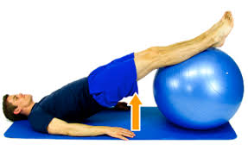

1. Stand with feet shoulder width apart & with a band around your knees.
2. Stride to your left against the resistance of the band slightly squatting down. Hands can be as shown or out in front to aid balance.
3. Then bring legs back together before repeating.
4. Keep repeating for the length of room or hall then repeat in opposite direction x2

Sumo or Side walks with Band

